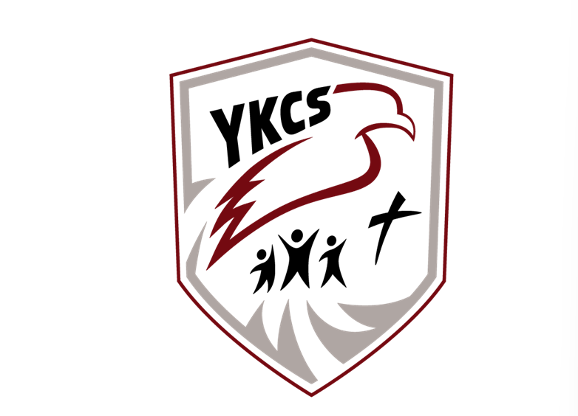
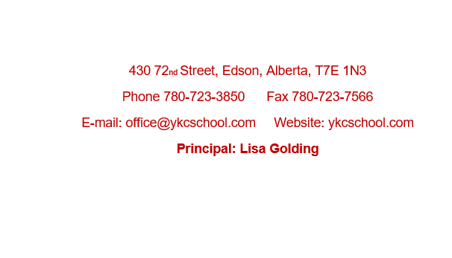

Annual Education Results Report
Winter 2023

Table of Contents
Accountability Statement for the Education Plan 3
Whistleblower Protection: 4
Profile of the School Authority 4
Mission Statement: 4
Vision Statement: 5
Statement of Faith: 5
Values and Characteristics 6
Domain: Local &Societal Content 6
Rationale: 6
Education Plan Outcome 7
YKCS Measures and Results 7
Community Demographics 7
Family Faith Demographics* 7
Domain: Student Growth and Achievement 8
Rationale: 8
Education Plan Outcome 8
Provincial Achievement Tests 8
Diploma Exams 9
High School Completion Results 9
Citizenship 10
Student Learning Engagement 10
Domain: Teaching & Leading 11
Rationale: 11
Education Plan Outcome 11
Domain: Learning Supports 12
Rationale: 12
Welcoming, Caring, Respectful, and Safe Learning Environment 12
Access to Support & Services 12
Domain: Governance 13
Rationale: 13
Parental Involvement 13
Financial Report 14
Appendix #1- AERR Original Data 15
High School Completion Rates 16

Accountability Statement for the Education Plan

The Annual Education Results Report for Yellowhead Koinonia Christian School Society for the 2022/2023 school year was prepared under the direction of the Board of Directors in accordance with the responsibilities under the Private Schools Regulation and the Ministerial Grants Regulation. The Board is committed to using the results in this report, to the best of its abilities, to improve outcomes for students and to ensure that all students in the school authority can acquire the knowledge, skills and attitudes they need to be successful and contributing members of society.
This Annual Education Results Report for 2022/2023 was approved by the Board on November 27, 2023.
Respectfully submitted,

Shane Vanderkooi Lisa Golding

YKCS Board Chair Principal

Whistleblower Policy:

The policy was adopted March 26, 2014. There were no disclosures reported to the chief officer of Yellowhead Koinonia Christian School.

Whistleblower Protection:

Profile of the School Authority
Yellowhead Koinonia Christian School (Y.K.C.S.) is located at 430-72 Street, Edson, Alberta. We are an accredited, independent, interdenominational school which is parent owned and parent operated with parental involvement in all aspects of school operation. Each year members in good standing with the Society elect parents to our local school board.
The school has existed for over 40 years but in June of 1997 became a part of Koinonia Christian Schools and is currently a premier member of this organization. YKCS is also a member of the Association of Independent Schools and Colleges of Alberta (AISCA) and the Association of Christian Schools International (ACSI).

The building, completed in 2003, includes a gymnasium, chapel, and commercial kitchen. The school building contains 8 classrooms, administration offices, chapel, and a resource room. In 2022-2023 we have 6.0 FTE Teachers, 4 FTE special needs assistants, 1 home school coordinator, 1.0 FTE administrator. There are 1.0 FTE programming assistants. We operate with a 1.0 FTE Receptionist/Bookkeeper.

We offer full and part time ECS programming. The student/teacher ratio being low enables much individual attention, and provides a stimulating, interactive environment where students can experience success.

Y.K.C.S offers Christian based education and is committed to spiritual and academic excellence in all things for the glory of God.

Mission Statement:
Yellowhead Koinonia Christian School is a Christ-centered discipleship school that exists to assist Christian families in developing the spiritual lives and academic potential of its students.

Vision Statement:
YKCS has a vision to glorify our Lord Jesus Christ by preparing students through a quality education characterized by academic excellence and a foundation of truth as revealed in God’s Word. As a distinctly Christian, independent school, YKCS is committed to an example of integrity and service in our community and in developing graduates who understand, embrace and live out a thoroughly Christian worldview.

Statement of Faith:
- We believe that the Bible, containing the 66 books of the Old and New Testaments, is the only inspired, inerrant, infallible Word of God and is the final authority on the Christian faith and life. (II Timothy 3:16; II Peter 1:21).
- We believe there is only one God, who exists eternally in three equal persons — Father, Son, and Holy Spirit — and who created out of nothing the heavens and the earth and all that is in them by the power of His spoken word (Genesis 1:1; Genesis 1:26; Psalm 33:6; Matthew 28:19; John 1:1-3; Mark 1:9-11; Hebrews 11:3).
- We believe that Jesus Christ is both true God and true man (Exodus 3:13-15 and John 8:58-59; John 1:1-18; John 10:30-33; Galatians 4:4-5; Philippians 2:5-8; Hebrews 2:14-18). We believe in His virgin birth (Isaiah 7:14; Matthew 1:18-23; Luke 1:26-35); His sinless life (Hebrews 4:15; Hebrews 7:26); His miracles (John 2:11); His substitutionary death (Romans 4:25; Romans 5:8; Galatians 3:13-14; Hebrews 2:9); His physical resurrection (Luke 24:39-43; I Corinthians 15:1-22); His ascension to the right hand of the Father (Mark 16:19; Luke 24:50-53); and His personal, visible, and bodily return in power and glory to judge the living and the dead (Acts 1:11; Revelation 20:11-15; Revelation 22:12).
- We believe that men and women were created by God in His own image (Genesis 1:27; Genesis 9:6); that marriage was instituted by God whereby a man and a woman are joined together in lifelong commitment to faithful companionship, and that Biblical marriage is the only legitimate and acceptable context for sexual intimacy (Genesis 2:20-24; Matthew 19:4-6; Romans 7:2; I Thessalonians 4:1-8; Hebrews 13:4). We believe that all men and women are born spiritually separated from God because of sin (Genesis 3:23-24; Romans 3:10-12; I John 1:8-10), and are incapable of being reconciled to God apart from the work of Jesus Christ (Romans 5:6-8; Acts 4:12; Ephesians 2:1-5).
- We believe in the absolute necessity of rebirth by the Holy Spirit for salvation (John 3:1-3; I Peter 1:23). We believe that man is justified (declared righteous) by God on the single ground of the righteousness of Jesus Christ (namely, His sacrificial and atoning death on the cross to pay the penalty for sin, and His perfect obedience) freely given to all who believe in Him. We believe that this saving work and perfect righteousness of Jesus Christ can only be received by faith alone (Isaiah 53:1-12; Jeremiah 23:6; Matthew 20:28; John 3:16-19; John 5:24; Romans 3:21-26; Romans 4:1-3; Romans 5:8-19; Romans 10:1-10; I Corinthians 1:30; II Corinthians 5:21; Galatians 2:21; Ephesians 2:8-9; Philippians 3:7-9; I John 4:10).
- We believe in the physical resurrection of both the saved and the lost. Those who are saved will rise to eternal life, and those that are lost to eternal punishment (Matthew 16:27; John 5:28-29; Matthew 25:46; I Corinthians 15:12-17).
- We believe that the Church is the body of born-again believers in fellowship with Christ and with fellow believers (I Corinthians 12:12-13; Ephesians 2:19-21; Hebrews 10:25).
- We believe in the presence and power of the Holy Spirit, who indwells believers enabling them to live a Godly life (Romans 8:13-14; I Corinthians 3:16; I Corinthians 6:19-20; Ephesians 2:10; Ephesians 5:15-21). 9)
- We believe that mankind was created in the image of God, after His likeness and therefore has transcendent, intrinsic worth (Genesis 1:27). The murderous destruction of any human life from conception to natural death is unjustifiable and wrong in the sight of God.
- We believe that God wonderfully and immutably creates each person as male or female. These two distinct, complementary genders together reflect the image and nature of God (Genesis 1:26-27). Rejection of one’s biological sex is a rejection of the image of God within that person.
- We believe that men and women were created by God in His own image (Genesis 1:27; Genesis 9:6), that marriage was instituted by God whereby a biological man and a biological woman are joined together in lifelong commitment to faithful companionship, and that Biblical marriage is the only legitimate and acceptable context for sexual intimacy (Genesis 2:20-24; Matthew 19:4-6; Romans 7:2; I Thessalonians 4:1-8; Hebrews 13:4).
- God has established three institutions within human society—the family, the state, and the church—with the Triune God reigning supreme over all. Each institution, under God, has a sphere of authority with jurisdictional limits that must be respected. The state, at all levels, exists to preserve order in society, to ensure justice for citizens and residents, and to protect families and churches, providing them with the freedom and safety necessary to fulfill their God-given responsibilities (Pro. 8:15-16; Dan. 2:21; John 19:11; Rom. 13:1-7; I Pet. 2:13-16; Tit. 3:1). The church is duty bound to promote the well-being of state and society through its moral and spiritual guidance, its worship and supplication of almighty God (II Chron. 7:14; I Tim. 2:1-6), and its charitable institutions and works (Mat. 5:13-16; Eph. 2:10; I Tim. 6:18; Tit. 2:14, 3:8, Heb. 10:24; I Pet. 2:12).

Values and Characteristics

Koinonia
Koinonia is the Greek word often translated as community or fellowship. God made people to live together, and we are committed to being a community that lives and learns together according to the grace and joy we have received in Christ as the children of God. As people learning in koinonia our lives are turned outward such that each person, being wonderfully different, having a unique, God-given place in their community and world. We affirm the glory of each person according to their distinct likeness to Christ and as such each student is encouraged to grow ever more intellectually, emotionally, socially and spiritually to embody the glory of love of God to each other and society around us. Beyond this we find fellowship with our local community of churches who support us and other schools who share our fundamental mission across Alberta.

Evangelical
Our faith is centered on God who loves and in love revealed Himself to people in many different ways throughout history. As an evangelical community we believe that tradition, reason and experience are essential to understanding God and life. More than each of these those, the Bible is the primary way that God currently is revealing Himself and His will to humanity and is the rule of faith as the Spirit leads us in understanding it.

Redemptive
God created all things good and glorious according to His creative wisdom. Though marred by sin, Christ, our perfect teacher and example, shows us that humanity, culture and creation are to be redeemed. This is the mission of God’s people as they are led by the love of Christ and the power of the Spirit. Joining God in His mission to redeem His world requires that we come to know what it means to live humbly and seek justice as we manifest God’s love for His whole creation.

Domain: Local & Societal Content

Rationale:
As an independent Christian school parents only enroll their children – at personal cost to themselves – if they believe that the school provides what their children need and, therefore, need to remain conscientiously accountable to them when setting priorities for the school culture and academics. We also are dependent on churches to communicate our existence to new members of the community, so it is essential that the school is trusted by churches as an institution that is faithful to the values of the Christian community at large. Finally, our students enter the community through service projects, work experience and RAP, so having a strong relationship with community partners affords our students more opportunities in their education and afterward.

Education Plan Outcome
School stakeholders, particularly parents and students, but also alumni and local church pastors, are engaged to give input on priorities for the school.

Comment
We are blessed to be supported in prayer and financial assistance from 6 local churches for multiple years. Our enrollment growth is because of parent satisfaction and their sharing about our program to friends throughout the community of Edson.

YKCS Measures and Results

Community Demographics
 | 2018 – 2019 | 2019 - 2020 | 2020 - 2021 | 2021 - 2022 | 2022-2023
In-School Students K-12 | 70 | 81 | 74 | 71 | 92
Homeschool Students | 17 | 9 | 13 | 16 | 17
Preschool Students | 6 | 10.5 | 6 | 7 | 6
Self-Identifying FNMI Students | 9 | 9 | 9 | 6 | 6
Visible Minority Students | 10 | 9 | 9 | 13 | 5
Financial Assistance Students | 4 | 6 | 4 | 2 | 8
Severe Disability | 5 | 6 | 3 | 4 | 6
PUF | 0 | 1 | 0 | 1 | 1
Mild / Moderate / Gifted | No Data | No Data | 10 | 6 | 7
ESL / ELL Students | No Data | 8 | 7 | 9 | 17

Family Faith Demographics*
 | 2020 - 2021 | 2021 - 2022 | 2022-2023
Carrot Creek (non-denominational) | 1 | 2 | 1
Alliance | 4 | 3 | 5
Baptist | 11 | 13 | 12
C.R.C. | 1 | 1 | 2
Family of Faith | 5 | 2 | 1
Mennonite | 3 | 3 | 2
Pentecostal | 6 | 5 | 3
Undeclared | 8 | 1 | 6
United | 1 | 2 | 0
Other Nondenominational | - | 4 | 8
Catholic | - | 1 | 1
*At least one primary care giver from each family is required to sign that their faith is aligned with the school’s statement of faith.
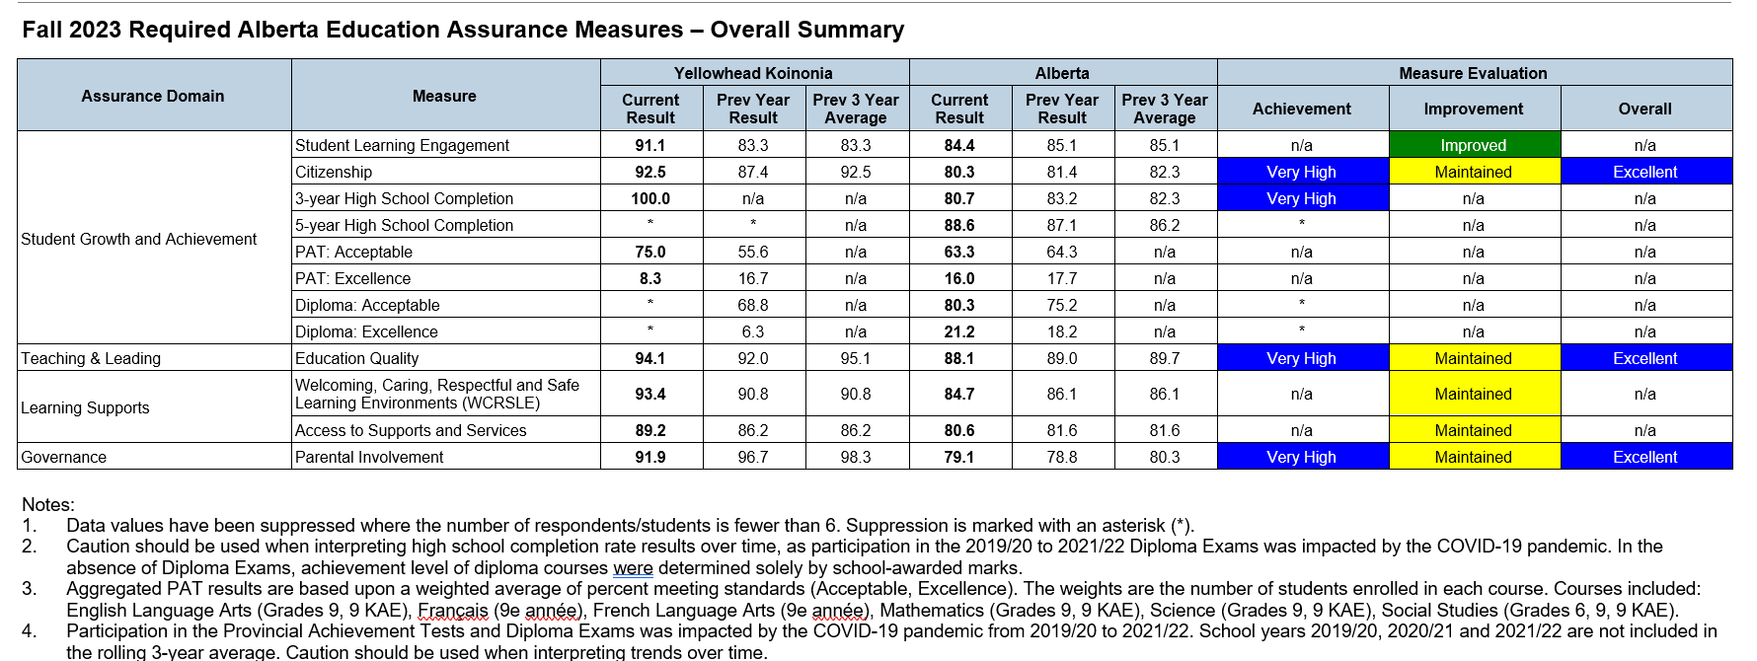

Domain: Student Growth and Achievement

Rationale:
Based on standardized test results, our parent surveys and discussion among staff it is clear that there is need for systematic emphasis on Math and ELA.

Education Plan Outcome
Students demonstrate competencies and capacities according to the Alberta POS with an emphasis on numeracy and literacy.

Comment
PAT and Diploma results reported are only from the January sitting. 2 forest fire evacuations and 1 flood throughout May/June of 2023 resulting in our students being exempt from exams.

Provincial Achievement Tests
Overall PAT Results By Number Enrolled
 | 2019 | 2020 | 2021 | 2022 | 2023
Acceptable Standard
YKCS | 62% | N/A | N/A | 52.8% | 75%
Province | 73.8% | N/A | N/A | 67.3% | 63.3%
Standard of Excellence
YKCS | 12% | N/A | N/A | 11.1% | 8.3%
Province | 20.6% | N/A | N/A | 18% | 16%

Please see appendix for Assurance Report Data

Diploma Exams
Overall Diploma Results By Number Writing
Overall Acceptable Standard | 2019 | 2020 | 2021 | 2022 | 2023
Overall Acceptable Standard
YKCS | * | N/A | N/A | 68.8% | *
Province | 83.6% | N/A | N/A | 75.2% | 80.3
Overall Standard of Excellence
YKCS | * | N/A | N/A | 6.3% | *
Province | 20.6% | N/A | N/A | 18.2% | 21.2

Please see appendix for Assurance Report Data

High School Completion Results
The data presented by the government is not entirely a fair representation of YKCS in that a number of students, upon graduation, have gone on to post-secondary institutions that are not recognized for this data (eg. Peace River Bible College). As such, when this is considered, our transition rate to post-secondary is close to, if not exceeding Alberta averages. Our data, however, does not account for completion of post-secondary programs.

 | 2013-2014 | 2014-2015 | 2015-2016 | 2016-2017 | 2017-2018 | 2018-2019 | 2019-2020 | 2020-2021 | 2021-2022 | 2022-2023 | Totals & Percentages
Grade 12 In-Class Students | 5 | 4 | 2 | 4 | 1 | 1 | 5 | N/A | 7 | 3 | 32
Completed Diploma | 5 | 2 | 2 | 4 | 1 | 1 | 4 | N/A | 7 | 3 | 29/32  91%
Completed Certificate of Completion | N/A | N/A | N/A | N/A | N/A | N/A | 1 | N/A | N/A | N/A | 1/32  3%
Did not Complete High School | N/A | 2 | N/A | N/A | N/A | N/A | N/A | N/A | N/A | N/A | 2/32  6.3%
Went on to Recognized Post-secondary | 1 | 2 | No Data | 1 | 1 | 1 | 1 | N/A | 3 | 0 | 10/32  32%
Went on to Unrecognized Post-secondary | 4 | 0 | 1 | 0 | N/A | N/A | 3 | N/A | 2 | 0 | 10/32  32%

Notes:
For the government results please see Appendix 1.
2 In the 2020-2021 school year we did not have any grade 12 students.

Citizenship

Percentage of teachers, parents and students who are satisfied that students model the characteristics of active citizenship.
Achievement |  |  |  | Improvement |  |  | Overall
Very High |  |  |  | Maintained |  |  | Excellent
Overall |  | 2019 |  | 2020 |  | 2021 | 2022 |  |  | 2023
YKCS |  | 99.1% |  | 97.6% |  | 97% | 87.4% |  |  | 92.5%
Province |  | 82.9% |  | 83.3% |  | 83.2% | 81.4% |  |  | 80.3%
Percentage of teachers, parents and students who are satisfied that students model the characteristics of active citizenship.
 | 2019 |  | 2020 |  | 2021 |  |  | 2022 | 2023
Parent | 100% |  | 100% |  | 100% |  |  | * | 93.8%
Student | 97.4% |  | 95.1% |  | 90.9% |  |  | 74.8% | 83.5%
Teacher | 100% |  | * |  | 100% |  |  | 100% | 100%

Student Learning Engagement

The percentage of teachers, parents and students who agree that students are engaged in their learning at school.
Achievement |  | Improvement |  | Overall
N/A |  | Improved |  | N/A
Overall | 2019 | 2020 | 2021 | 2022 | 2023
YKCS | N/A | N/A | 92.9% | 83.3% | 91.1%
Province | N/A | N/A | 85.6% | 85.1% | 84.4%

The percentage of teachers, parents and students who agree that students are engaged in their learning at school.
 | 2019 | 2020 | 2021 | 2022 | 2023
YKCS Overall | N/A | N/A | 92.9% | 83.3% | 91.1%
Parent | N/A | N/A | 100% | * | 97.4%
Student | N/A | N/A | 78.6% | 66.6% | 75.9%
Teacher | N/A | N/A | 100% | 100% | 100%

Domain: Teaching & Leading

Rationale:
To support the school’s strategic priorities, it is essential that we provide opportunities for staff to interact with other professionals, sharing strategies, resources, and gain new perspectives on teaching that will grow their capacity to meet the various needs of students.

Education Plan Outcome
Staff will continuously improve their professional practice according to the TQS and local priorities, responding with skill and competence to the unique learning needs of all students.
Comment
YKCS Staff are very committed to Professional Development and improvement of their practice. During the 2022-2023 school year 2 teachers committed to a mentorship course on Biblical Integration. Each year different professional development opportunities are presented to staff to assist in this growth. In the first half of 2023 many professional development sessions were offered to support the new curriculum.

Percentage of teachers, parents and students satisfied with the overall quality of basic education.
Achievement |  | Improvement |  | Overall
Very High |  | Maintained |  | Excellent
Overall | 2019 | 2020 | 2021 | 2022 | 2023
YKCS | 95.7% | 98.2% | 96.3% | 92.0% | 94.1%
Province | 90.2% | 90.3% | 89.6% | 89% | 88.1%

Percentage of teachers, parents and students satisfied with the overall quality of basic education.
 | 2019 | 2020 | 2021 | 2022 | 2023
YKCS Overall | 95.7% | 98.2% | 96.3% | 92.0% | 94.1%
Parent | 93.3% | 100% | 99.2% | * | 93.5%
Student | 96.7% | 96.4% | 89.6% | 84% | 91.5%
Teacher | 97.1 | * | 100% | 100% | 97.2%

Domain: Learning Supports

Rationale:
According to our Christian identity, YKCS should be a place where staff, students and families work together in the context of their real unity in Christ to make the school a community of learning characterized by peace, joy, patience, kindness, self-control, and generosity. Furthermore, when people do not feel safe they are not effective workers or learners.

Welcoming, Caring, Respectful, and Safe Learning Environment

The percentage of teachers, parents and students who agree that their learning environments are welcoming, caring, respectful and safe.
Achievement |  | Improvement |  | Overall
N/A |  | N/A |  | N/A
Overall | 2019 | 2020 | 2021 | 2022 | 2023
YKCS | N/A | N/A | 98% | 90.8% | 93.4%
Province | N/A | N/A | 87.8% | 86.1% | 84.7%

The percentage of teachers, parents and students who agree that their learning environments are welcoming, caring, respectful and safe.
 | 2019 | 2020 | 2021 | 2022 | 2023
YKCS Overall | N/A | N/A | 98% | 90.8% | 93.4%
Parent | N/A | N/A | 100% | * | 94.2%
Student | N/A | N/A | 94% | 81.7% | 85.9%
Teacher | N/A | N/A | 100% | 100% | 100%

Access to Support & Services

The percentage of teachers, parents and students who agree that students have access to the appropriate supports and services at school.
Achievement |  | Improvement |  | Overall
N/A |  | N/A |  | N/A
Overall | 2019 | 2020 | 2021 | 2022 | 2023
YKCS | N/A | N/A | 96.3% | 86.2% | 89.2%
Province | N/A | N/A | 82.6% | 86.1% | 80.6%

The percentage of teachers, parents and students who agree that students have access to the appropriate supports and services at school.
 | 2019 | 2020 | 2021 | 2022 | 2023
YKCS Overall | N/A | N/A | 96.3% | 86.2% | 89.2%
Parent | N/A | N/A | 100% | * | 90.8%
Student | N/A | N/A | 89% | 72.4% | 80.1%
Teacher | N/A | N/A | 100% | 100% | 96.7%

Domain: Governance

Rationale:
It is clear biblically that God-gives fundamental responsibility to parents for the education of their children and yet the whole community of faith that surrounds each child bears responsibility as well. As such, inviting parents especially and community members additionally is essential to fulfilling our mission and meeting the needs of our faith community.

Parental Involvement

Percentage of teachers and parents satisfied with parental involvement in decisions about their child's education.
Achievement |  | Improvement |  | Overall
Very High |  | Maintained |  | Excellent
Overall | 2019 | 2020 | 2021 | 2022 | 2023
YKCS | 97.3% | 100% | 93.8% | 96.7% | 91.9%
Province | 90.2% | 90.3% | 89.6% | 89% | 79.1%

Percentage of teachers and parents satisfied with parental involvement in decisions about their child's education.
 | 2019 | 2020 | 2021 | 2022 | 2023
YKCS Overall | 97.3% | 100% | 93.8% | 96.7% | 91.9%
Parent | 94.6% | 100% | 87.6% | * | 93.8%
Teacher | 100% | * | 100% | 96.7% | 90.0%

Financial Report

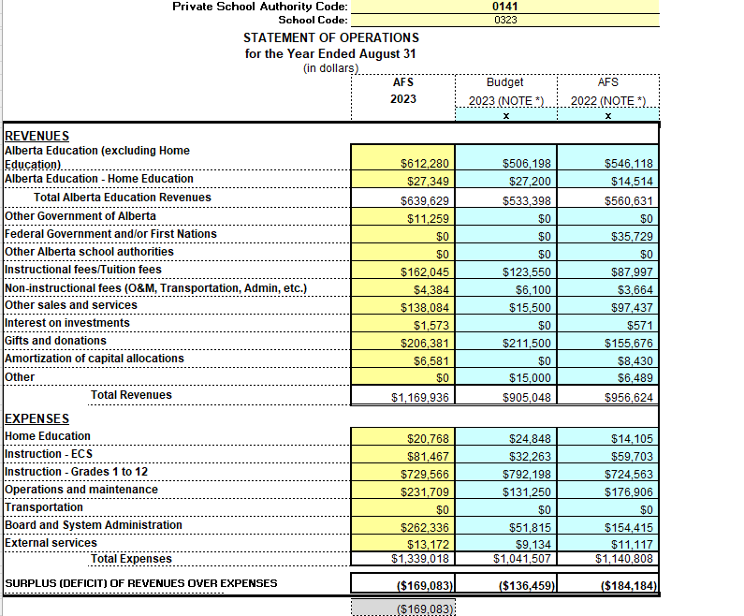

Appendix #1- AERR Original Data

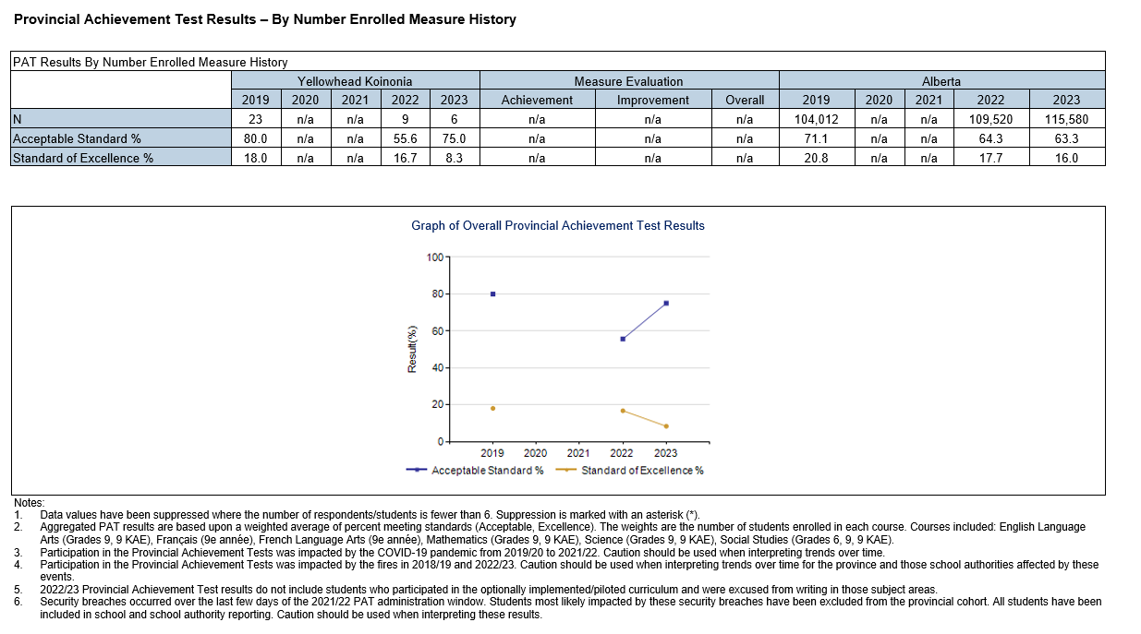
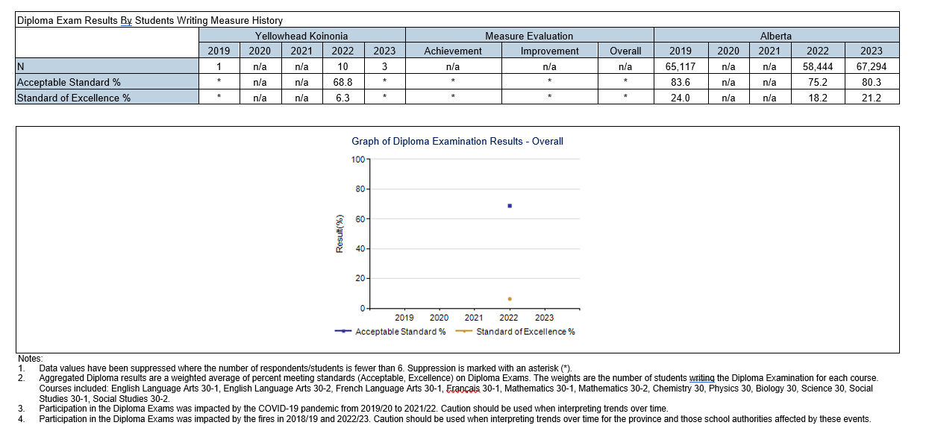
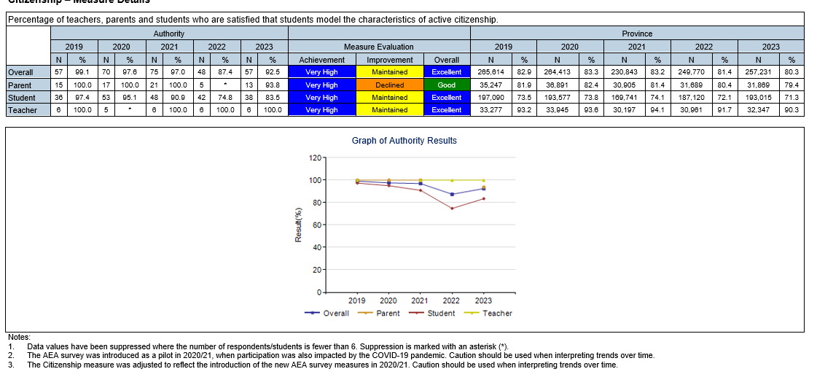
High School Completion Rates - Measure History
